CPN Board Election 2014
Photo:

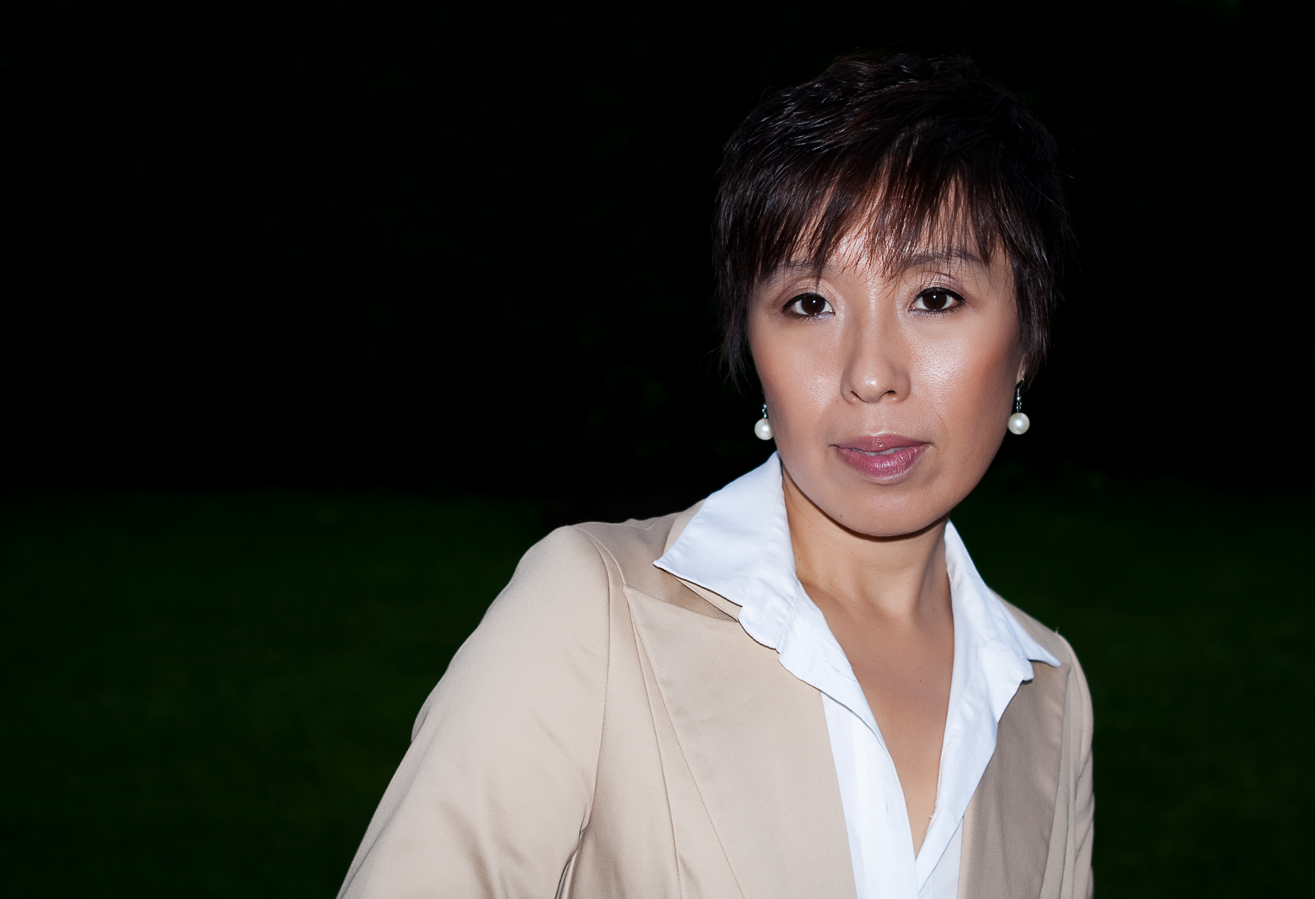

Candidate | Name: | Yun Wang | Sex: | female

Degree/Major/University: MD. PhD
Working organization/Title: Oslo University Hospital-DNR/ senior consultant (Overlege)

Experience in social work including contribution to CPN:
As a board member of Chinese biological and medical association in Norway.

Why do you want to serve to CPN as a board member?
To make our life in Norway colorful.

Contact information email or telephone (optional)
wangbonnie67@yahoo.com 45217069

