CPN Board Election 2014
Photo:
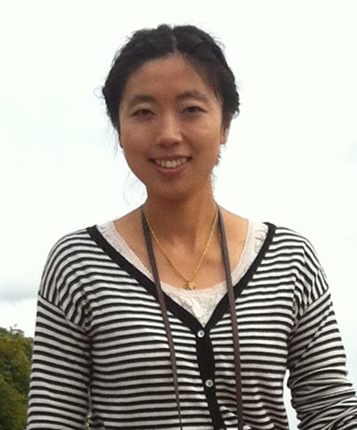
Candidate | Name: | Wanshan Wang | Sex: | Female

Degree/Major/University: IT engineer IT and Electronics Engineering IHK
Working organization/Title: Dincare AS, Business Manager

Experience in social work including contribution to CPN:
Work in CPN board since 2010.
Help to organize CPN trip to Biofarm and Halden in 2014.
Organize Chinese Young people get-together party in 2012 and 2013.
Host and organize CPN Chinese New Year party in 2011 and 2012.
Organize table tennis training and tournament in 2011 and 2012.

Why do you want to serve to CPN as a board member?
It is grateful to work in CPN board and help Chinese people in Norway.

Contact information email or telephone (optional)
xiaoshan616@gmail.com
41258380

