A Satisfied Visit to Hadeland Bio-industries

The second activity of CCI (Competence Center for Immigrants) project – ‘Meeting with Norwegian Industry’ was organized by CPN (Chinese Professional in Norway) on Saturday, 20th September. 53 participants from 14 nationalities joined the trip. The activity was financed by The Directorate of Integration and Diversity (IMDi).

This trip included visits to 3 plants at Hadeland region, which has been committed to and recognized as sustainable developments in Norway. In the bus to Hadeland, Mr. Helge Midttum, the program leader at the agricultural office of Gran Kommunen, introduced the bioenergy developments in the region as a guide for the entire trip.

The first visit was to Trollmyra Waste Plant (Hadeland og Ringerike Avfallsselskap, HRA for short) in Jevnaker. Mr. Amond Bø introduced how HRA worked to generate energy from waste and raw materials. After the presentation, he took the participants around in the plant and explained how household wastes were converted to biogas and other recyclable materials.

The second visit was to Energy Farm at Brandbu. The manager Erik Eid Hohle presented his Energy Farm and the exhibition center “The Global Greenhouse” – bioenergy in theory and practical experiences. This Energy Farm with 11 employees has developed a self-supported system meeting to 85-90% of their needs in energy consumptions by following ways:
- Heating production using wood chips from own forest
- Solar heat production
- Liquid biofuels for transportation

The final visit was to Gran varmesentral og fjernvarmeanlegg, an automatic controlled heating-center. As one of co-founders/owners, Mr. Jan Helge Ekeren gave a very brief of the history of the senter and knowledge about how the senter works today. He talked also about the related Norwegian regulations, laws, and the national energy situation. Participants were deep impressed by the modern and automatic systems in the warm-center and the strong-minded people who built up this private owned green energy plant.

All presentations were both interesting and educational. The speakers got a lot of good and professional questions from the participants. They were very happy to meet such very engaged audiences. CPN got very good feedbacks from the participants too. Most of them told that they gained knowledge about renewable energy development in Norway, and some of them have established the contacts with those companies. They wish CPN can arrange more similar visits in order to build up more connections to the industry.

The presentations can be downloaded here.
- Presentation of Hadeland og Ringerike Avfallsselskap by Amond Bø
- Presentation of Energy Farm by Erik Eid Hohle
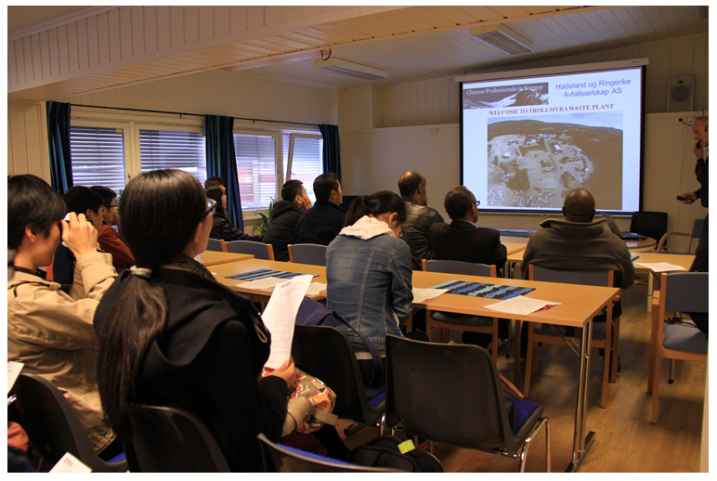
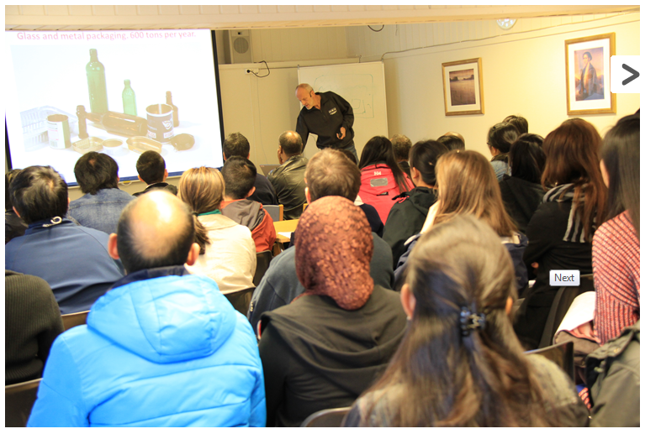
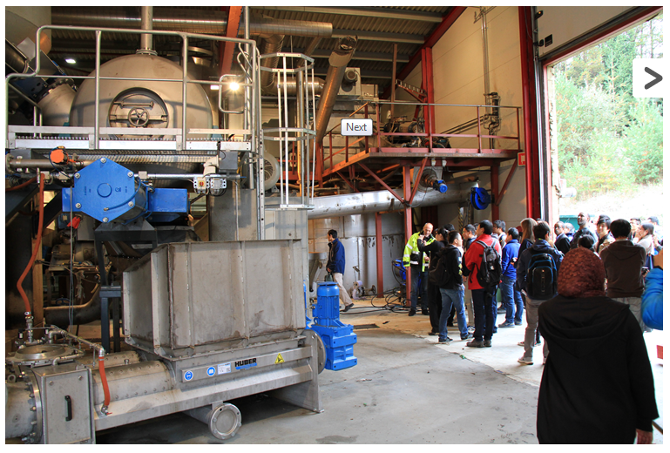
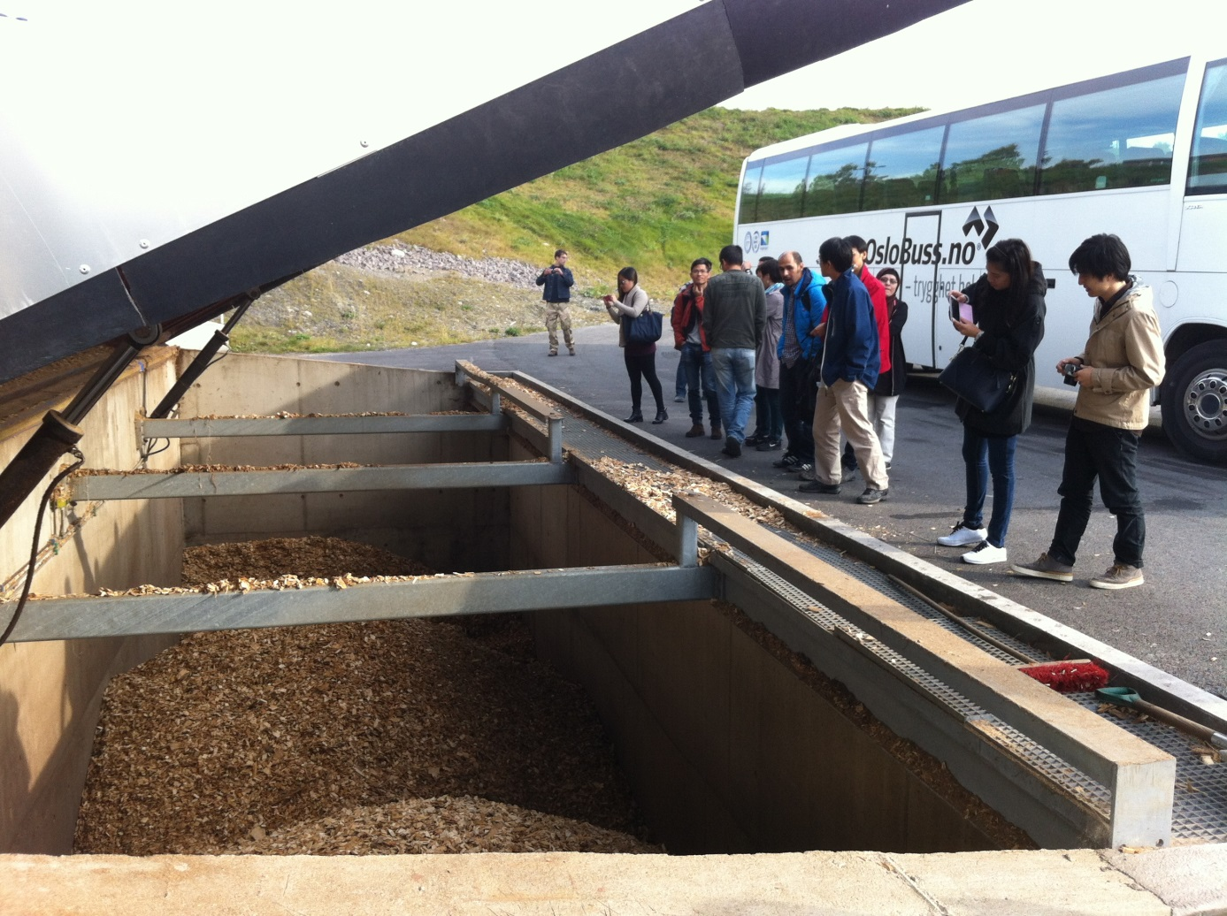
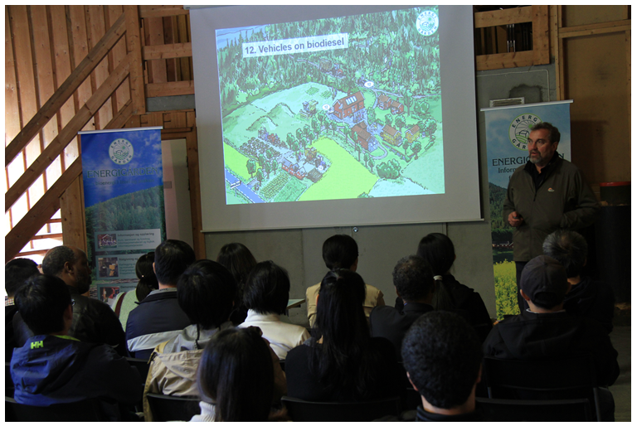
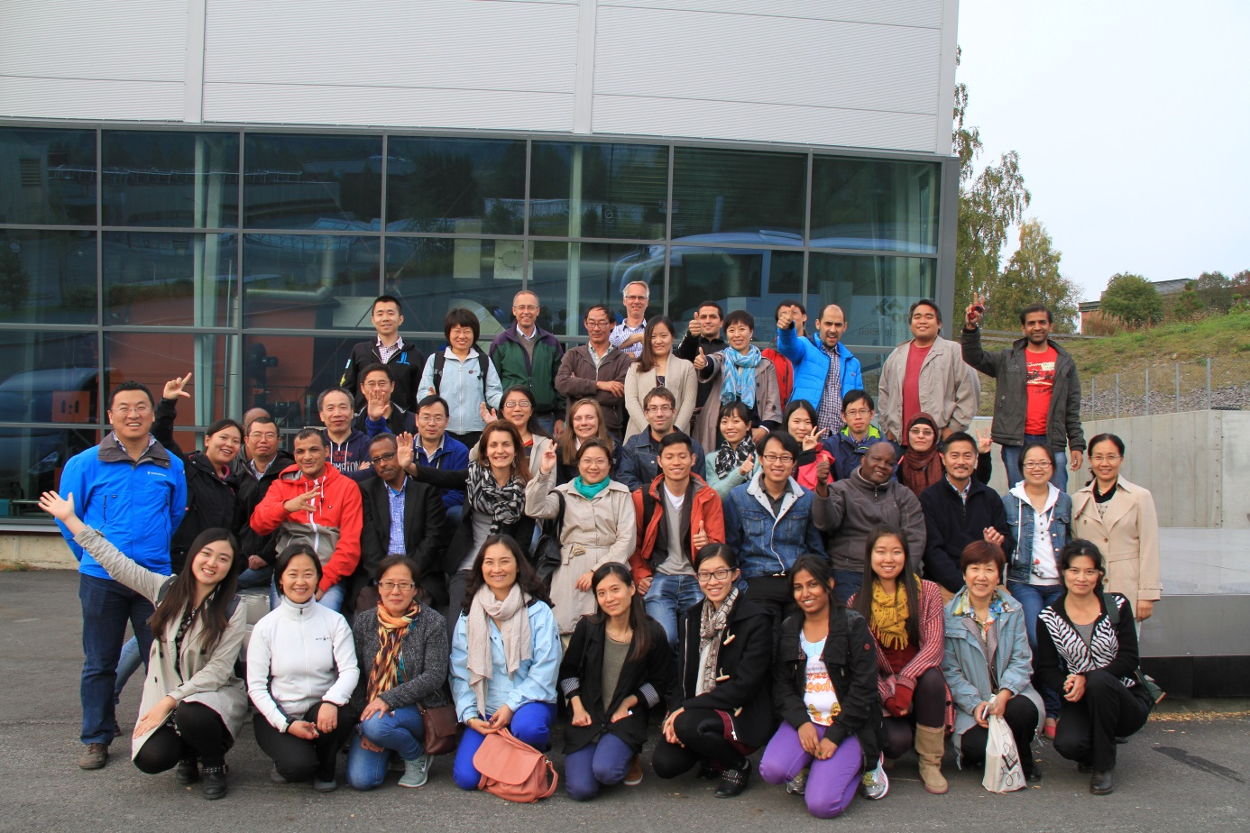

(Reported by Xinli Wang; Photo: Yunyong Wang, Xie Wei and Xiuhua Zhang)

